MySQL Assignment – Clauses and Joins

1. Introduction
This assignment focuses on querying and analysing employee data using MySQL. The database and tables created in Assignment 1 were used as the foundation for this assignment.
The provided DML statements were used to populate the Departments, Location, and Employees tables with data. SQL queries were then executed to retrieve, filter, sort, group, aggregate, and join the data.

2. Objectives
The main objectives of this assignment are:
- To retrieve distinct values using DISTINCT.
- To rename columns using aliases with AS.
- To filter records using the WHERE clause.
- To update missing employee information.
- To sort records using ORDER BY.
- To limit the number of records using LIMIT.
- To perform calculations using aggregate functions.
- To group records using GROUP BY.
- To filter grouped results using HAVING.
- To retrieve related information using INNER JOIN, LEFT JOIN, and RIGHT JOIN.

3. Database and Tables
The database employee was created in Assignment 1 and continued to be used for this assignment.
The following tables were used:
- Departments
- Location
- Employees
The provided employee data contains department information, location information, and employee records.

4. Data Insertion
The provided DML script was executed to insert data into the three tables.
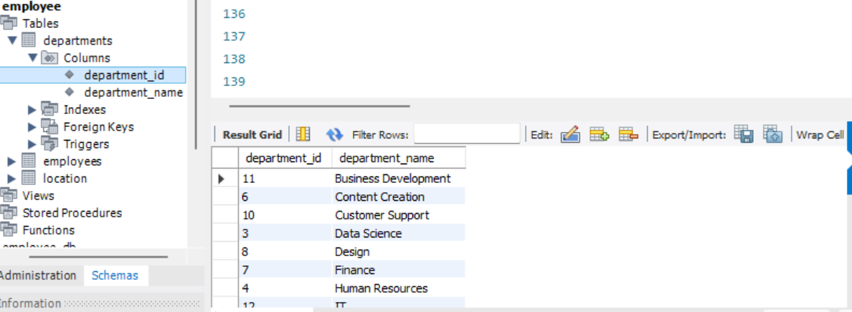
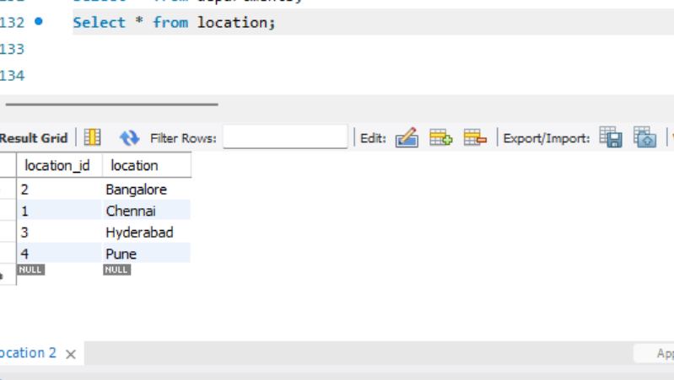
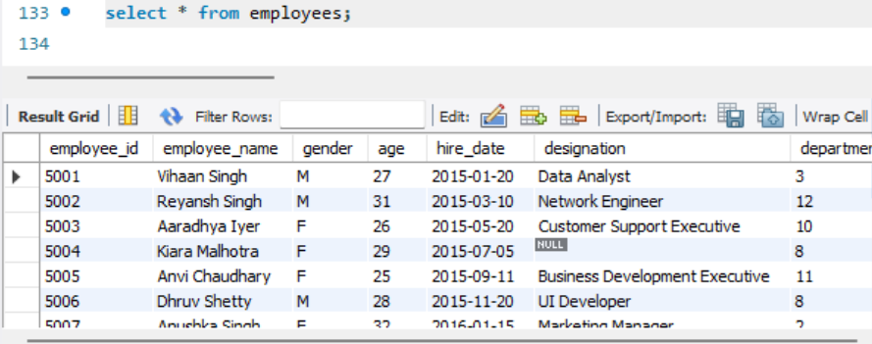

1. Distinct Values:
⦿ a query to retrieve distinct salaries from the Employees table.
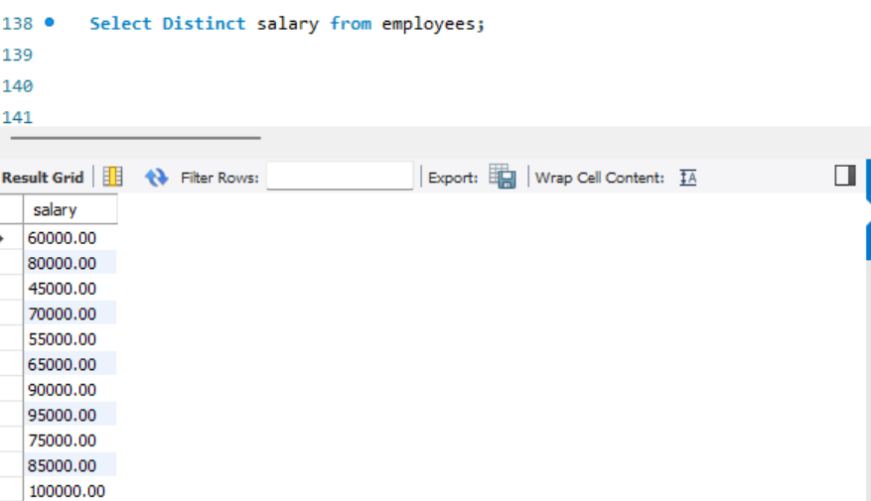

2. Alias (AS):
⦿ Provide aliases for the "age" and "salary" columns as "Employee_Age" and "Employee_Salary", respectively.
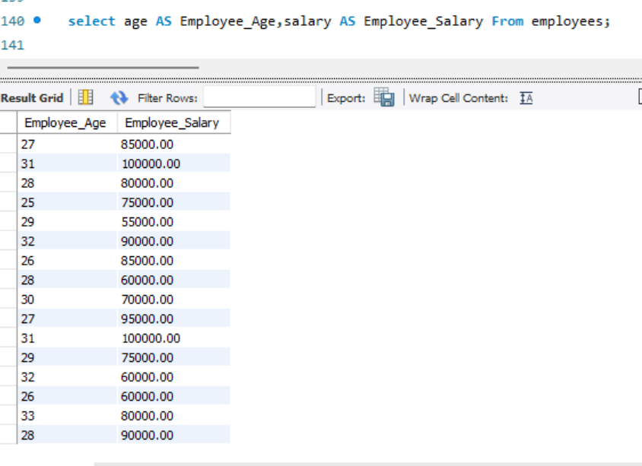
3. Where Clause & Operators:
⦿ Retrieve employees with a salary greater than ₹50000 and hired before 2016-01-01.
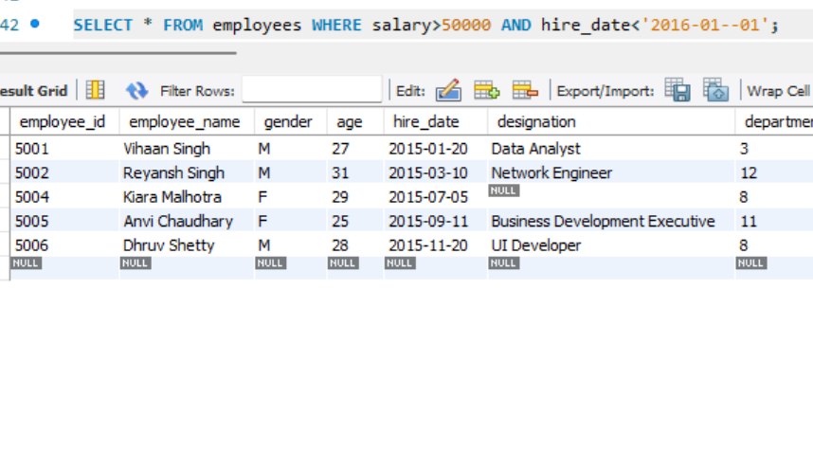
⦿ Find the employee whose designation is missing and fill it with "Data Scientist".
The provided data contains employee 5004, Kiara Malhotra, with a NULL designation.
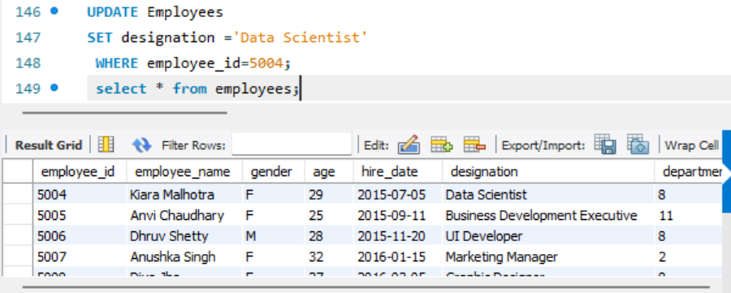
Sorting and Grouping Data:
1. ORDER BY:
⦿ Find employees sorted by department ID in ascending order and salary in descending order.
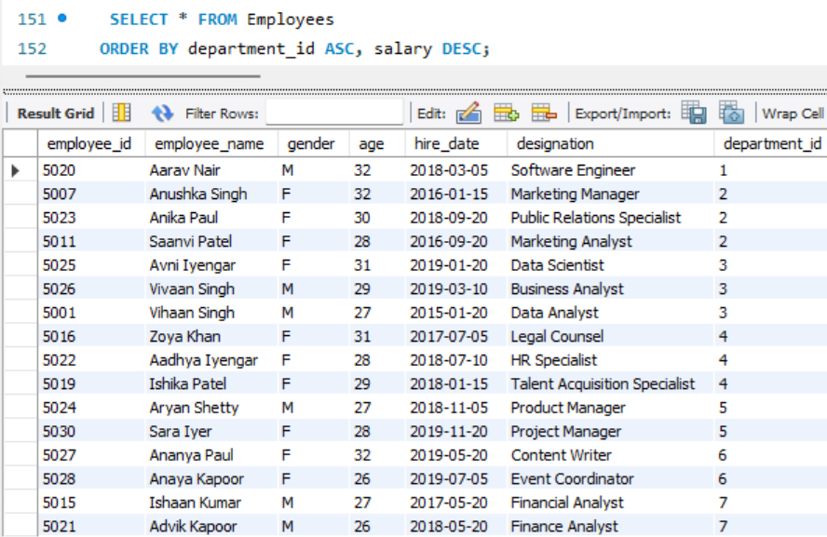

2. LIMIT:
⦿ Display the first 5 employees hired in the year 2018.
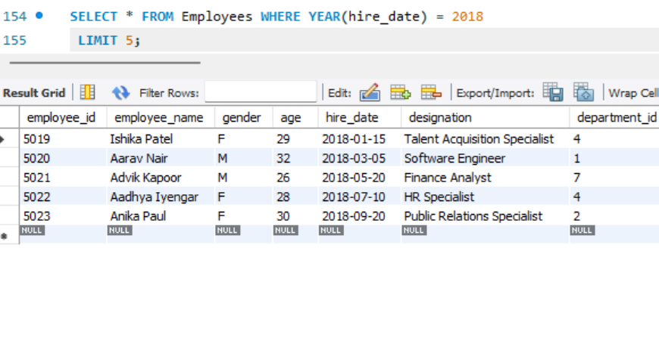
3. Aggregate Functions:
⦿ Calculate the sum of all salaries in the Finance department.
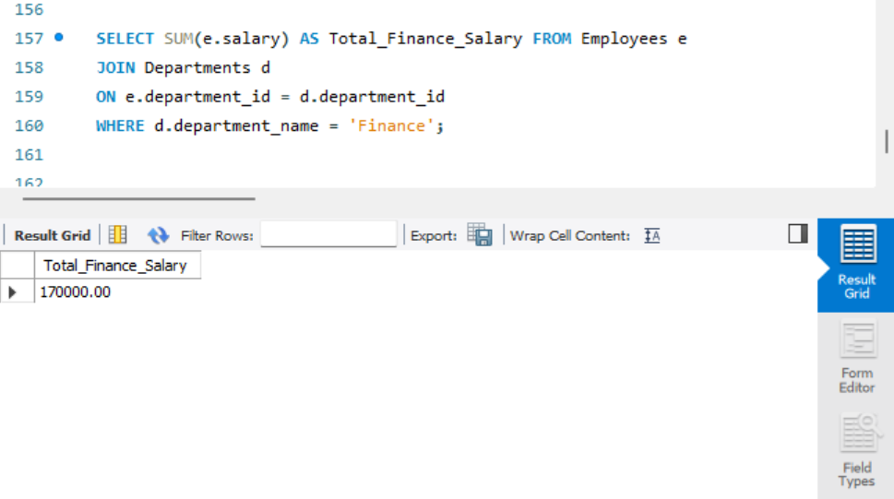

⦿ Find the minimum age among all employees.
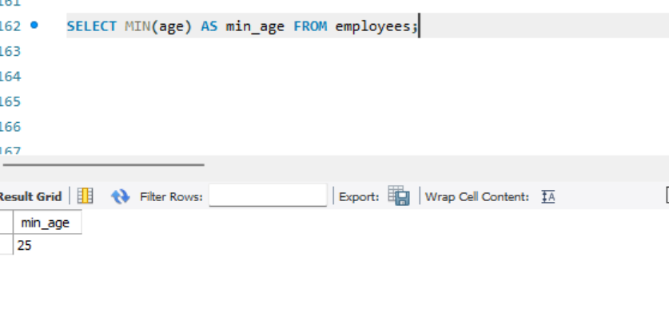
4. GROUP BY:
⦿ List the maximum salary for each location.
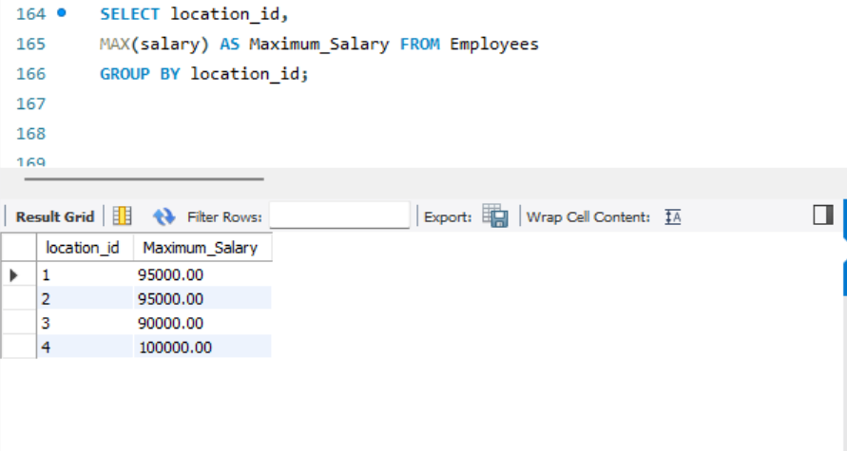
⦿ Calculate the average salary for each designation containing the word 'Analyst'.
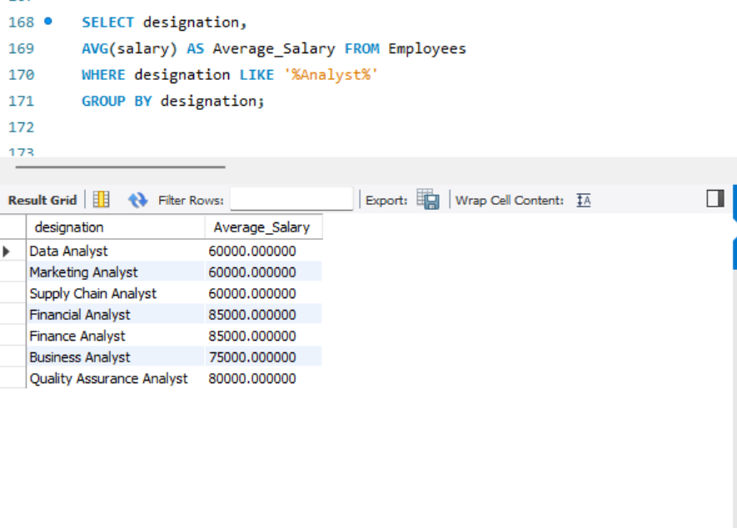
5. HAVING:
⦿ Find departments with less than 3 employees.
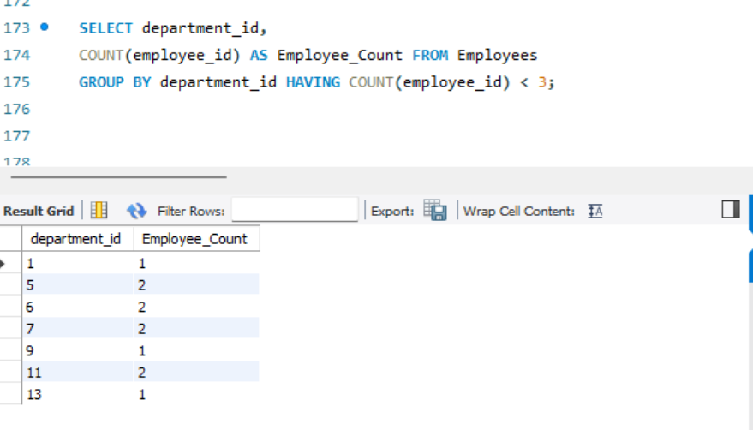
⦿ Find locations with female employees whose average age is below 30.
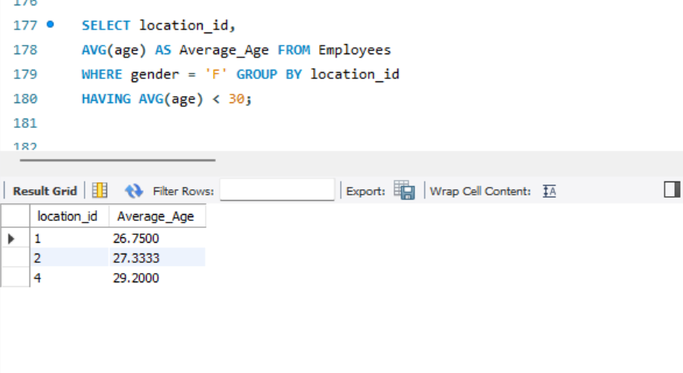

Joins:
1. Inner Join:
⦿ List employee names, their designations, and department names where employees are assigned to a department.
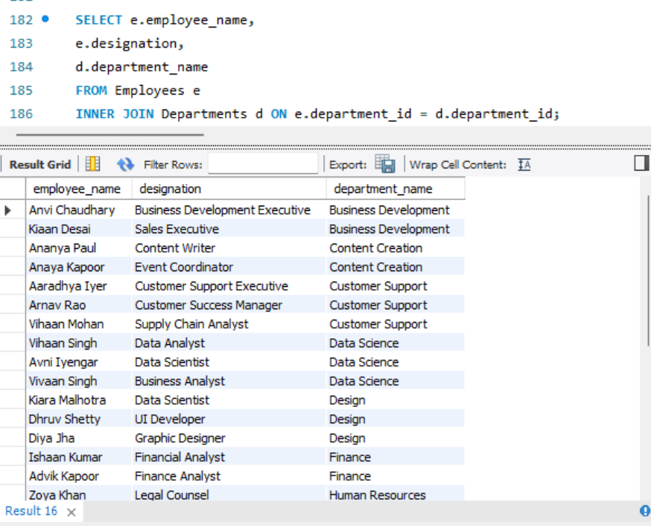

2. Left Join:
⦿ List all departments along with the total number of employees in each department, including departments with no employees.
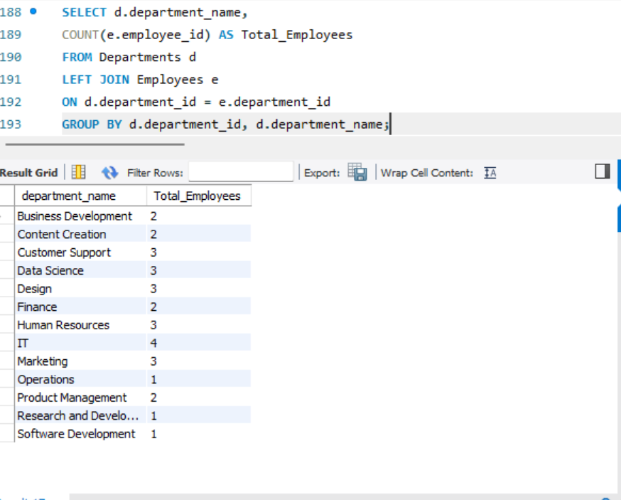

3. Right Join:
⦿ Display all locations along with the names of employees assigned to each location. If no employees are assigned to a location, display NULL for employee name.
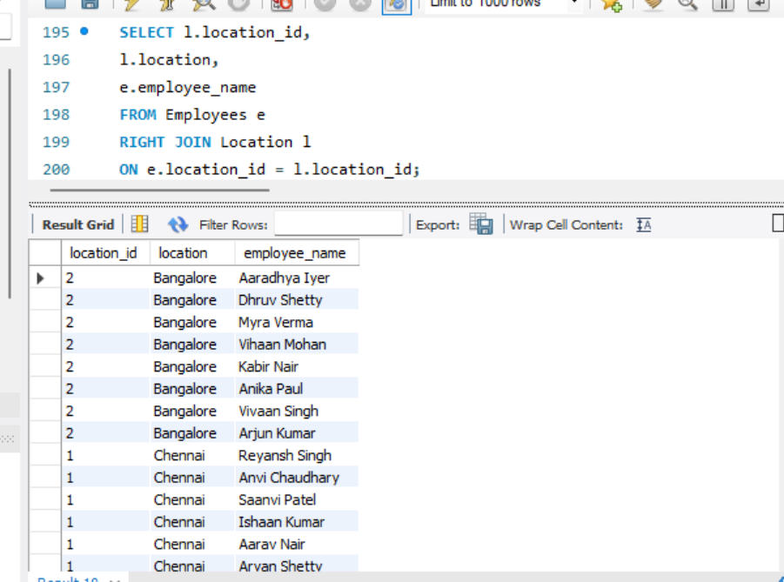

CONCLUSION:
This assignment provided practical experience in querying and analysing data using MySQL. Various SQL commands and clauses such as DISTINCT, AS, WHERE, ORDER BY, LIMIT, aggregate functions, GROUP BY, and HAVING were used to retrieve meaningful information from the employee database.
The assignment also demonstrated the use of INNER JOIN, LEFT JOIN, and RIGHT JOIN to combine information from multiple related tables. Missing employee information was identified and updated using SQL. Overall, the assignment helped develop a better understanding of how SQL can be used to filter, organize, summarize, and analyse relational data.

